# Translating with Prompts

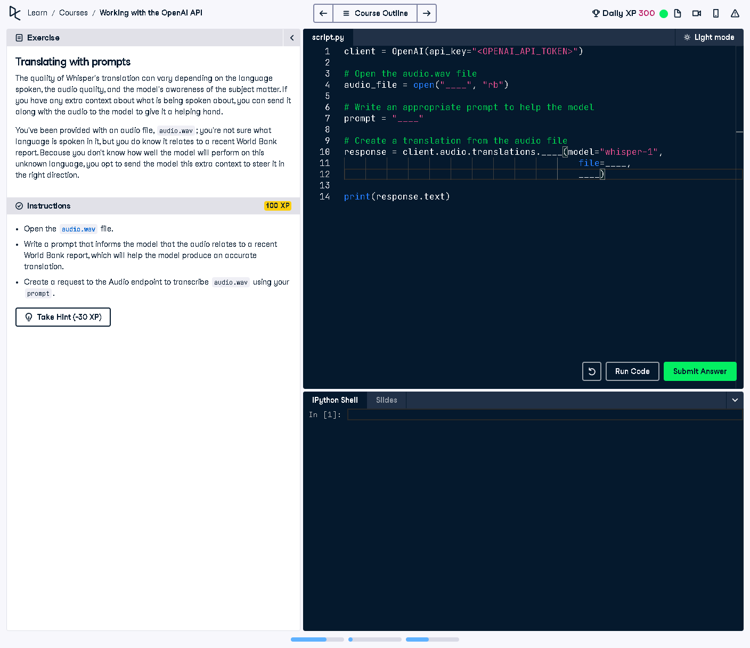

## Question:

The quality of Whisper's translation can vary depending on language spoken, audio quality, and subject matter awareness. To improve accuracy, a prompt can be given to provide context about the audio content.

## Explanation:

In this task, we are provided with an audio file ('audio.wav') and need to supply a prompt explaining that the content is related to a recent World Bank report. This will help Whisper generate a more accurate translation.

## Answer:

client = OpenAI(api_key="<OPENAI_API_TOKEN>")  
  
# Open the audio.wav file  
audio_file = open("audio.wav", "rb")  
  
# Write an appropriate prompt to help the model  
prompt = "The transcript contains a discussion on a recent World Bank Report."  
  
# Create a translation from the audio file  
response = client.audio.translations.create(model="whisper-1",  
 file=audio_file,  
 prompt=prompt)  
  
print(response.text)

## Explanation of the Code:

1. The OpenAI client is initialized with an API key.  
2. The audio file ('audio.wav') is opened in binary mode for reading.  
3. A prompt is set to inform the model that the audio relates to a World Bank report.  
4. The `client.audio.translations.create` function is called with the model, file, and prompt.  
5. The API response contains the translated text, which is extracted and printed.